The UKIRT Success Story

Richard Ellis (Caltech)

- Introduction

It’s a pleasure to come to Edinburgh to celebrate 30 years of UKIRT operations! All of us feel a close and personal affinity to this remarkable telescope. As with all observatories, it’s a combination of excellent support staff and innovative instrumentation which provides the basis for scientific success and it’s a privilege to summarize, albeit briefly, the key aspects and discoveries that continue to make UKIRT a world-beating facility.

The UKIRT story really is a remarkable one. For a modest financial investment, the observatory has played a pivotal role in infrared astronomy for 30 years. It has an unrivalled reputation for technical innovation, cost-effective operations and reliability. It hosts a dedicated staff who willingly take on new responsibilities as required, and work endlessly to achieve the best, often in a hostile environment. And above all, UKIRT has delivered many scientific `firsts’ and built the astronomical careers of many.

In this written version of my Edinburgh talk, I have inevitably had to skip over some of the more amusing aspects of UKIRT’s history, but I hope this brief summary conveys the spirit of my talk and the admiration I hold for this 4 metre telescope.

- Early History

The engineering concept for an infrared flux collector goes back to the late 1960’s and the influential figure of Jim Ring at Imperial College London. The Science Research Council funded the facility to the tune of £2.5M in 1975; in 2009 currency this still only amounts to £10M - the cost of a modest spectrograph for a 8 metre telescope! Construction was rapidly completed during 1976-78 with first light on July 31 1978 and a formal dedication ceremony on October 10 1978.

Others present will remember those early events better than I, but I do have the benefit of a remarkable filing system from my time on SRC/SERC/PPARC committees and can offer some insight into the early discussions.

The case for UKIRT as originally envisaged is succinctly captured at a Royal Astronomical Society meeting held on May 9th 1975 (soon after its funding approval) where Jim Ring states the case for a flux collector and justifies little attention to image quality the requirement for which is only 2 arcsec:

“the consequent saving in cost over an optical telescope is significant..(and) can be put into a larger diameter rather than accurate figuring and support systems” (Observatory 163, p95 1975).

But in February 1977, the minutes of the Astronomy II Committee of the ASR Board of SRC show that the Director of ROE (Vince Reddish) reports:

“now that experience has been gained in figuring the blank, it is apparent with
comparatively little extra work, 1 arcsec images can be obtained”.

The additional cost for this dramatic improvement in image quality was estimated by David S. Brown (Grubb Parsons) at only £12K! It’s actually typical of Grubb Parsons and the late Dr Brown that the company should be so cooperative in maximizing the effectiveness of the telescope.

I have also located the first UKIRT Newsletter (Figure 1a). (Notice the methodical Ellis stamp and prominent `tick’ that indicates I carefully digested its contents in 1979) Peredur Williams was the editor and promises a UKIRT Users’ Manual `soon’ (actually it appeared in 1981!). There was no integrating TV, the control computer had a majestic 28K RAM and the Newsletter describes how the observatory earthquake protection system was usefully `commissioned’ with a real Richter 5.1 event. In this historic document one sees a good example of the pioneering, even swashbuckling, spirit that was to become characteristic of UKIRT!

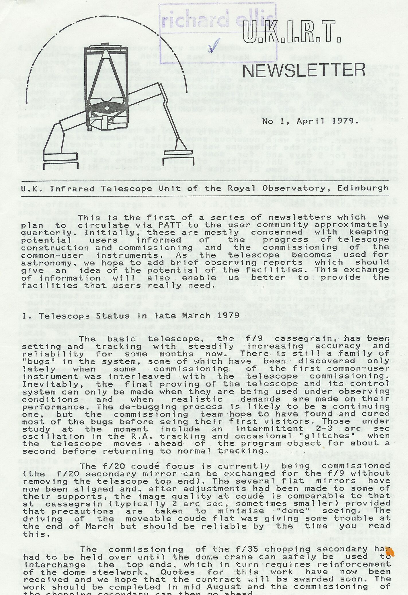 | 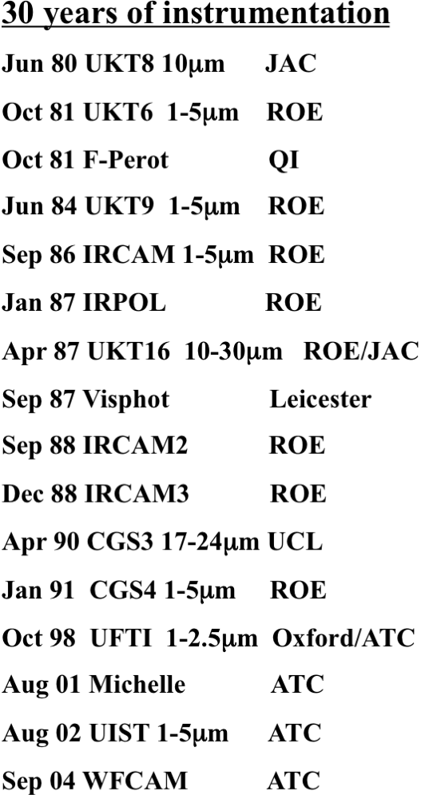

Figure 1 (a: left): UKIRT begins with the first Newsletter. (b: right) 30 years of innovative instrumentation – a new capability every 18 months!

- Technical Innovation

Before attempting to review some of UKIRT’s science highlights, let’s consider the remarkable innovations that have become characteristic of this observatory during the past 30 years.

From the outset the telescope set a new standard with its lightweight thin primary, and later the tip-tilt secondary and cooled primary mirror. However, UKIRT has also been in the vanguard in pioneering new operational concepts. It was amongst the first to routinely offer remote operations (from Edinburgh) and later service observing and flexible scheduling. The current model whereby selected PIs observe on behalf of a group of programs is unique and very popular with the community.

An unchanging telescope is a stagnant facility and UKIRT has also pioneered a continuous set of new instruments and upgrades (Figure 1b). Infrared capabilities undreamt of during the 1970’s such as integral field unit spectrographs and mosaiced arrays not only first appeared on UKIRT but set a pace and standard in science discovery that other facilities struggled to match.

Ten years after first light, by the time of the 19th UKIRT Newsletter in March 1989 (with Peredur Williams continuing his gallant service as Editor!), UKIRT had the world’s first common-user infrared array (c.f. Ian McLean’s contribution in this volume), a world-beating infrared spectrograph, CGS2, reaching K=14 (1σ 1s), a control computer with 16 Mb RAM and an image quality of better than 0.9 arcsec FWHM for 90%. Productivity was an impressive 50 refereed papers per year.

- Science Highlights

It’s hard to summarize 30 years of frontier science in a few remarks, so what follows is very much a personal selection arranged to span the panoply of instruments and science territories.

As someone who works on distant galaxies, I have to begin by emphasizing that the present dominance of near-infrared studies of the distant universe (now commonplace through NICMOS and WFC3/IR campaigns on Hubble and dedicated survey facilities such as VISTA), truly began at UKIRT. Despite the handicap of single-object photometers, UKIRT pioneered the Hubble diagram of distant radio galaxies and even undertook surveys of nearby galaxies – measured one by one - to construct the first field K-band galaxy luminosity function (Fig. 2). Later, with early infrared arrays, came the study of distant clusters of galaxies and their lensed arcs and faint galaxy counts. Quite simply, UKIRT moved into a league of its own. Most recently, the key role of UKIRT in pushing the frontiers was demonstrated in the discovery of the most distant z=8.26 gamma ray burst (Tanvir et al 2009).

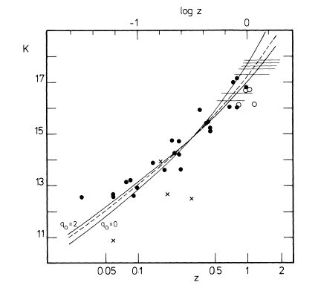 | 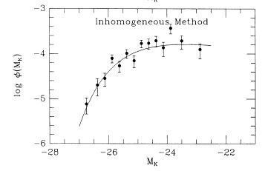

Figure 2: (left) the K-band Hubble diagram of distant radio galaxies from the study by Lilly & Longair (1984); (right) the first field galaxy luminosity function at near-infrared wavelengths from the study of Mobasher et al (1993).

Cooled grating spectrographs, CGS2 and later CGS4, championed wider territories in astrophysics. Highlights include the detection of the molecular H₃⁺ ortho-para doublet seen in absorption in young stellar objects by Geballe & Oka, a challenging observation that confirms the key role of this molecule in the production of complex molecules and ion-neutral interstellar chemistry, and systematic observations of L and T-dwarfs by Leggett, Geballe, Golimowski and collaborators which led to new classification methods and tests of model atmospheres in the sub-stellar regime (Fig. 3).

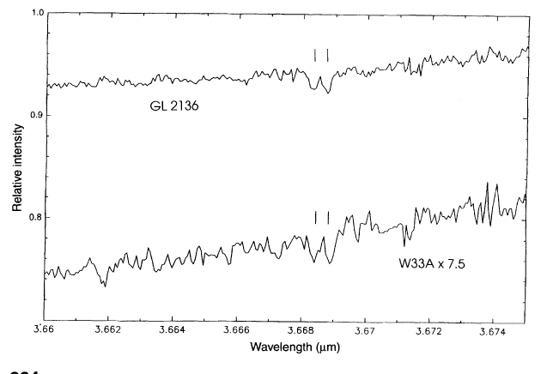 | 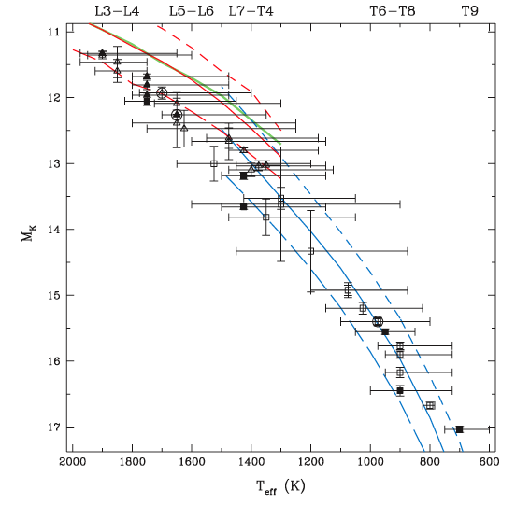

Figure 3: (left) Detection of the ortho-para doublet of H₃⁺ (marked) in the spectrum of two YSOs from the study of Geballe & Oka (1996). (Right) Luminosity-effective temperature relation for SDSS-selected L and T-dwarfs from Golimowski et al (2004).

For a telescope originally conceived without regard to image quality, I have chosen some examples that demonstrate how UIST and UFTI, instruments designed to match the excellent seeing on Mauna Kea, pushed the frontiers. Willott et al (2003) used UIST to locate and measure the black hole mass in a z=6.41 QSO; this is a pioneering observation exploiting UKIRT’s unique access to the redshifted Mg II emission line. Swinbank et al (2005) used the integral field unit of UIST to map the resolved dynamics of a z=2.385 sub-millimeter galaxy – consider the angular scale in Figure 4 in the context of Jim Ring’s remarks in 1975! Lucas & Roche (2000) exploited UFTI to chart young brown dwarfs and planets in the Trapezium region, thereby constraining the initial mass function down to an unprecedented 20 Jupiter masses.

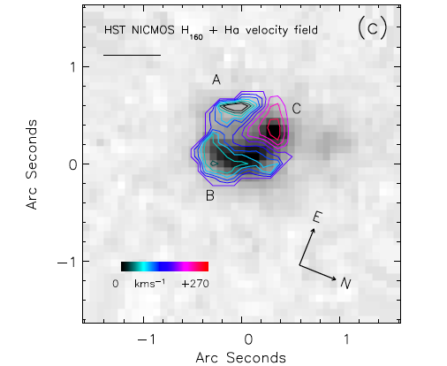 | 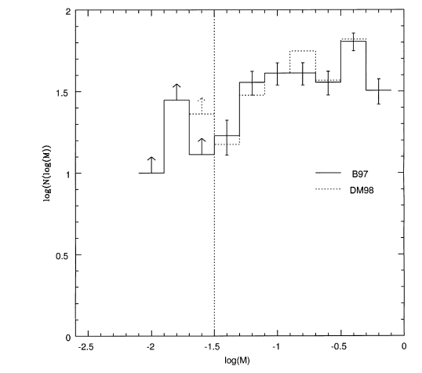

Figure 4: (Left) Resolved velocity field in Hα for a z=2.385 sub-mm galaxy from UIST IFU observations overlaid on a HST NICMOS H-band image demonstrating the importance of galactic outflows in early star-forming systems. Note the remarkable angular resolution (Swinbank et al 2005). (Right) Sub-stellar initial mass function (in solar units) from the Trapezium study of Lucas & Roche (2000).

Finally, to the present day and WFCAM. As others will discuss this remarkable survey capability in some detail, I thought I would steer clear of UKIDSS and just touch on two surveys which have exploited narrow-band imaging with this mosaiced array. HiZELS is an impressive set of surveys which exploits a narrow-band capability to either search for Hα imaging at z~1 or, more speculatively, Lyα imaging at very high redshift. In the former case, Sobral et al (2009) have surveyed the COSMOS and UDF fields to undertake a measurement of the star-formation density at z~1. Together with similar measures at other redshifts, a self-consistent star formation history has been deduced for the first time using the same tracer.

Closer to home, C. Davis and colleagues (Davis et al 2009) have mapped a phenomenal 8 deg² in Orion in the 2.122 micron emission band of molecular hydrogen, locating over 100 jects and associating them with protostellar objects. The level of detail in these maps is truly astonishing (Figure 5).

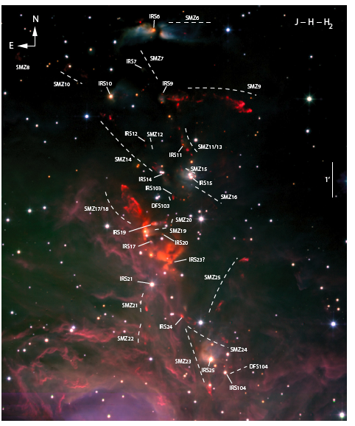 | 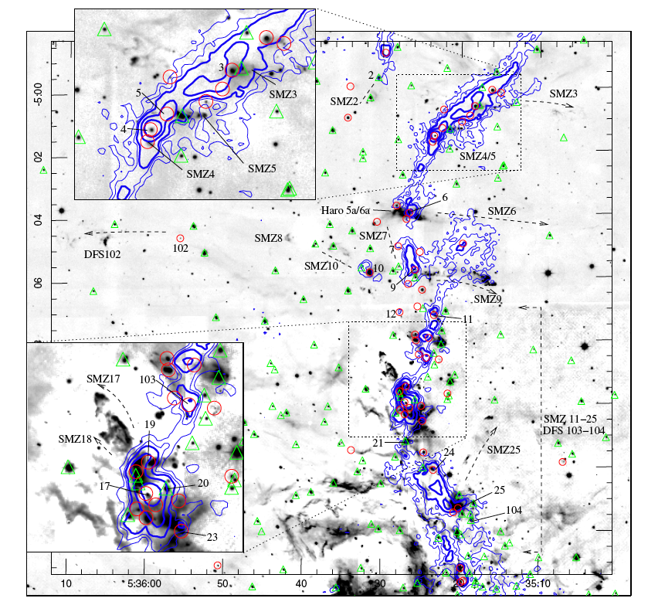

Figure 5: The remarkably detailed mapping of Orion in molecular hydrogen from the study of Davis et al (2009). (Left) Color composite of the region around M43 based on J, K and 2.122μm imaging; H₂ flows are labeled. (Right) 2.122μm image with protostars marked (with inset zooms at twice the scale). Contours refer to 1.2mm MAMBO data.

Studies of the productivity of UKIRT have underlined its global role in astronomy. Trimble et al (2005) and Trimble & Ceja (2007) examined the output and citation rate of the world’s 4-meter telescopes and place it alongside CFHT, NTT and WHT – optical telescopes which serve a more diverse community. Chris Benn (unpublished – see http://www.ing.iac.es/~crb/cit/9903_prelim.html) examined the fraction of highly-cited (top 2%) of world literature over 1999-2003 and reached similar conclusions. UKIRT ranks equal to CFHT, WHT and AAT and outpaces all other dedicated infrared telescopes (e.g. IRTF) by a significant margin.

- Summary and Future

So why is UKIRT so successful?

- It is blessed with being on a good site; Mauna Kea offers excellent seeing and a stable thermal environment.
- The joint operations with JCMT via the JAC is remarkably cost-effective.
- It has maintained a flexible suite of front-rank instruments
- It has championed creative operational models including remote observing and flexible scheduling, noting the importance of training young enthusiastic observers who then become its supporters.
- It has provided powerful online data processing capabilities
- It has shown again and again that it can reinvent itself, e.g. moving into high resolution imaging (UFTI) and now panoramic surveying (WFCAM/UKIDSS).

The future of UKIRT should therefore be bright! In 2005 I chaired an international review of UKIRT with a charge to make recommendations to PPARC on its “role and international context during 2005-2015 and options for development of the facility”. We took this charge very seriously but perhaps as an omen of what has since passed we received no financial guidelines from PPARC. It’s hard to see that our carefully-argued case for a bright future for UKIRT had any impact on STFC. As I write this summary of my September 2009 talk, the outcome of the Science Prioritisation Exercise 2010-2015 has just been published by STFC and UKIRT’s future in this period looks decidedly unclear.

UKIRT has been a great success not only for UK science but also in promoting the growth of infrared astronomy worldwide. It is one of the best examples of a telescope that has adapted to new technologies, far surpassing the modest goals envisaged in the 1970’s. It is sad that STFC should, apparently, not appreciate both the cost-effective operational model that has been a highlight of UKIRT over the past few years as well as the strategic importance of maintaining a UK presence on Mauna Kea amongst a set of international ground-based observatories which remain, collectively, the most productive scientifically. It will be sad indeed if the UK detaches itself from the Mauna Kea community, particularly given the glorious history blazed by UKIRT and its remarkable staff over the past 30 years.

References:

Davis, C. J. et al 2009 Astron. Astrophys. 496, 153
Geballe, T & Oka, T. 1996 Nature 384, 334
Golimowski, D. et al 2004 Astron. J. 127, 3516
Lilly, S.J. & Longair, M.S. 1984 MNRAS 211, 833
Lucas, P.W. & Roche, P.F. 2000 MNRAS 314, 858
Mobasher, B. et al 1993 MNRAS 263, 560
Sobral, D. et al 2009 MNRAS 398, 75
Swinbank, A.M. et al 2005 MNRAS 395, 401
Tanvir, N. et al 2009 Nature 461, 1254
Trimble, V. et al 2005 PASP 117, 111
Trimble, V. & Ceja, J.A. 2007 Astron. Nachr. 328, 983
Willott, C. et al 2003 Astrophys. J. 587, L15

Soon after I returned to Pasadena from the enjoyable meeting at Edinburgh, I learned of the sudden passing of Tim Hawarden who had been present at the meeting and did so much for the UKIRT upgrades program. Here is not the place for a tribute but this is a sad loss for Edinburgh and the global infrared community.

